NAME : KAVITAPU SWARNA VARSHINI
REG. NO: 192324081
DATE: 14-07-2026

Write a python program to solve 8 puzzle problem

AIM: To develop a Python program to solve the 8-Puzzle Problem using the A* (A-Star) Search Algorithm

ALGORITHM:
- Define the initial state and the goal state of the 8-puzzle.
- Calculate the heuristic value (Manhattan Distance) for the current state.
- Generate all possible moves by sliding the blank tile (0) in valid directions.
- Select the state with the minimum total cost (f = g + h) and repeat the process until the goal state is reached.
- Display the sequence of moves from the initial state to the goal state and terminate the program.

CODE:
from heapq import heappush, heappop
goal = [[1,2,3], [4,5,6],[7,8,0]]
start = [[1,2,3], [4,0,6], [7,5,8]]
def h(s):
return sum(abs(i-(v-1)//3) +abs(j-(v-1) %3)
for i, r in enumerate(s)
for j, v in enumerate(r) if v)
pq = [(h(start), 0, start)]
visited = []
while pq:
f, g, s = heappop(pq)
if s == goal:
print ("Goal State Reached")
for r in s:
print(r)
break
if s in visited:
continue
visited. append(s)
x, y = [(i, j) for i in range (3) for j in range (3) if s[i][j] ==0][0]
for dx, dy in [(-1,0), (1,0), (0, -1), (0,1)]:
nx, ny = x+dx, y+dy
if 0<=nx<3 and 0<=ny<3:
t = [r[:] for r in s]
t[x][y], t[nx][ny] = t[nx][ny], t[x][y]
heappush (pq, (g+1+h(t), g+1, t))

OUTPUT:
Goal State Reached
[1, 2, 3]
[4, 5, 6]
[7, 8, 0]

IMAGE:
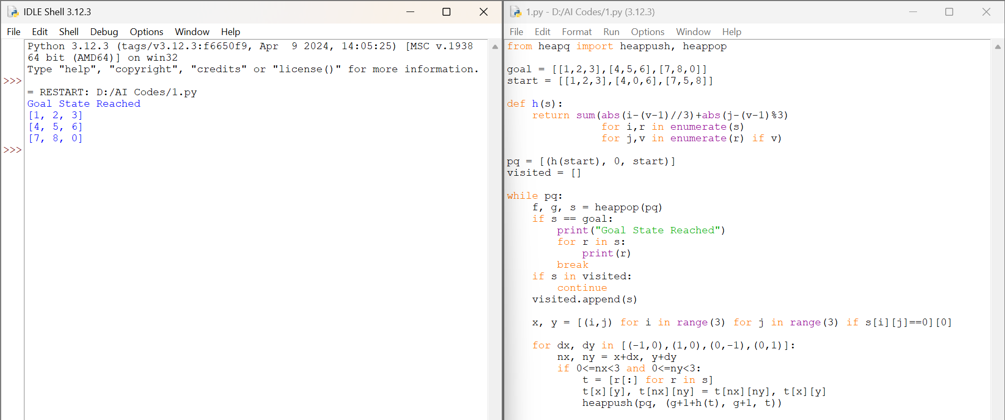

RESULT:
The Python program was executed successfully. The 8-Puzzle Problem was solved using the A* Search Algorithm with the Manhattan Distance heuristic, and the shortest sequence of moves from the initial state to the goal state was obtained successfully.

